1⃣ What is a Jenkins Pipeline?

A Jenkins Pipeline is a suite of automated processes that define how software is built, tested, and deployed in a Continuous Integration / Continuous Delivery (CI/CD) workflow.
It allows developers to define the entire build process as code using a file called Jenkinsfile.

💡 In simple terms:
A Jenkins Pipeline describes all the steps required to build and deliver an application automatically.

Typical stages in a pipeline include:

- Build – Compile the code

- Test – Run automated tests

- Package – Create deployable artifacts

- Deploy – Deploy to staging or production

Example pipeline flow:

Code Commit → Build → Test → Package → Deploy Benefits of Jenkins Pipeline:
- Pipeline as Code

- Easy to version control

- Supports complex workflows

- Enables CI/CD automation

- Better visualization of build stages

Different Ways to Write a Jenkins Pipeline
In Jenkins, pipelines can be written in two main ways: Declarative Pipeline and Scripted Pipeline. Both methods define the steps required to build, test, and deploy an application automatically.
- Declarative Pipeline:
Declarative Pipeline uses a simple and structured syntax. It is the most commonly used and recommended approach because it is easy to read, write, and maintain. It uses predefined sections such as pipeline, agent, stages, and steps to define the workflow. This format helps developers clearly organize different stages like build, test, and deploy.
- Scripted Pipeline:
Scripted Pipeline is written using Groovy scripting language. It provides more flexibility and control over the pipeline logic. Developers can write complex conditions, loops, and custom logic using Groovy code. However, it is more complex compared to the Declarative Pipeline.

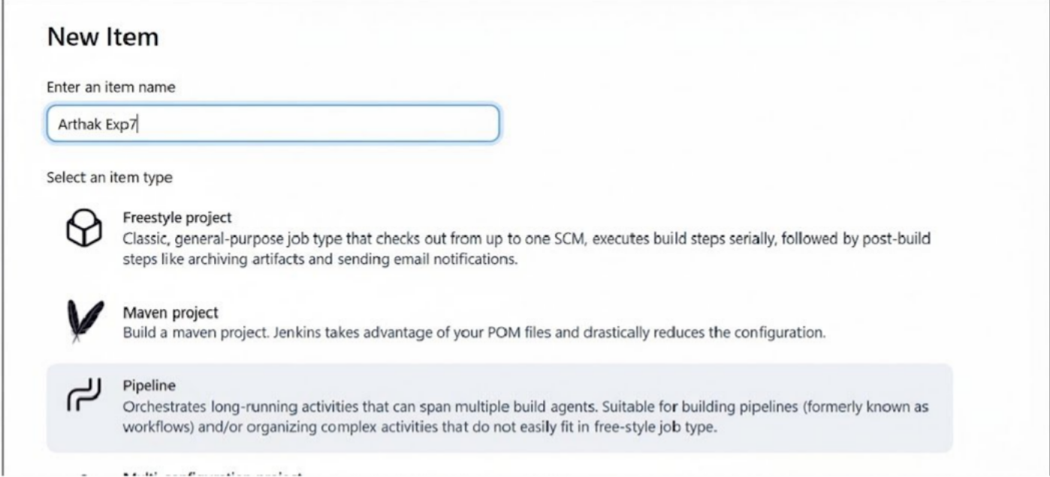
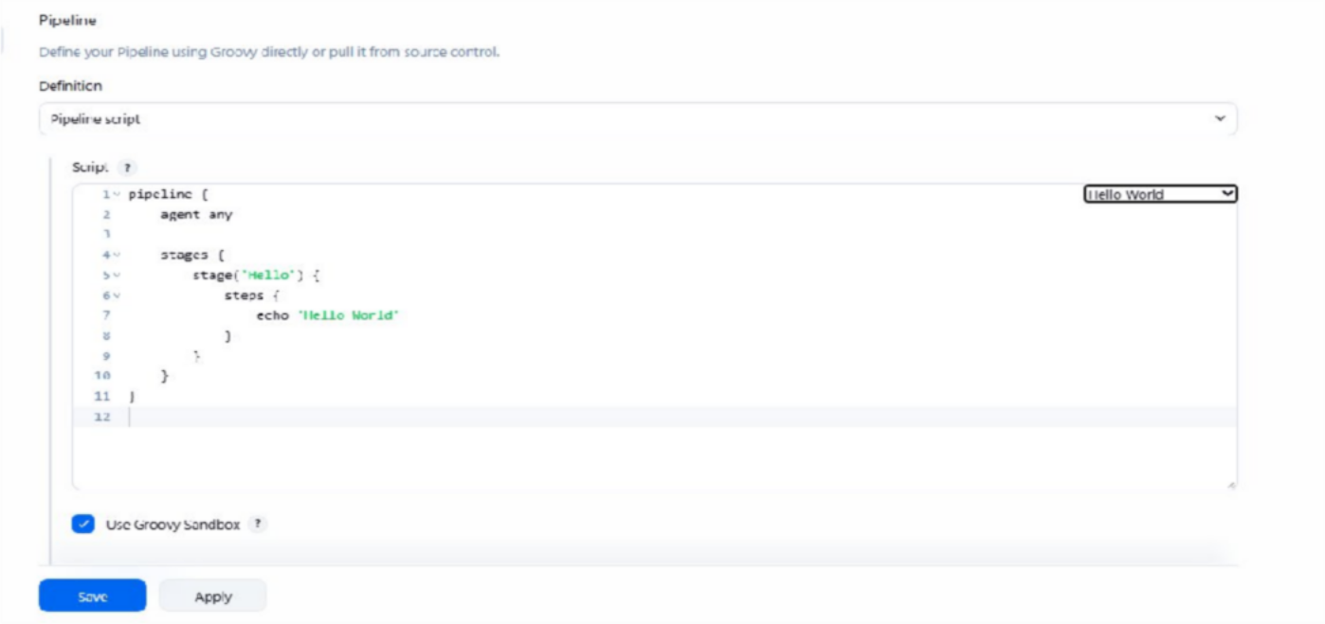
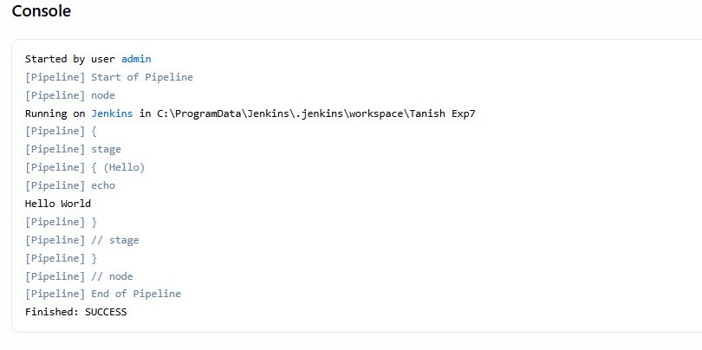
- Create and build Pipeline Hello World with pipeline script

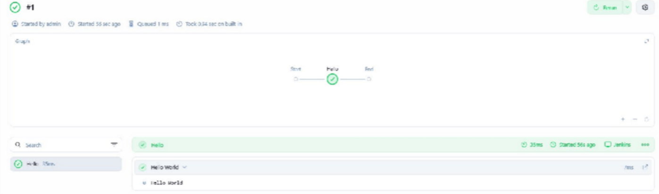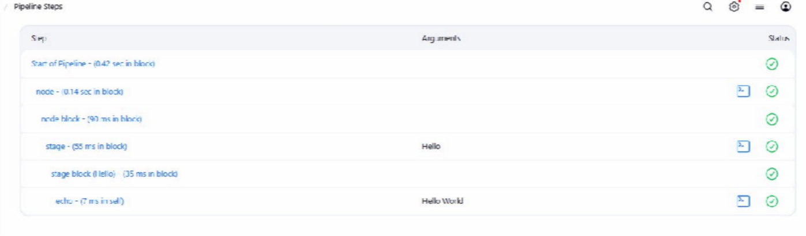

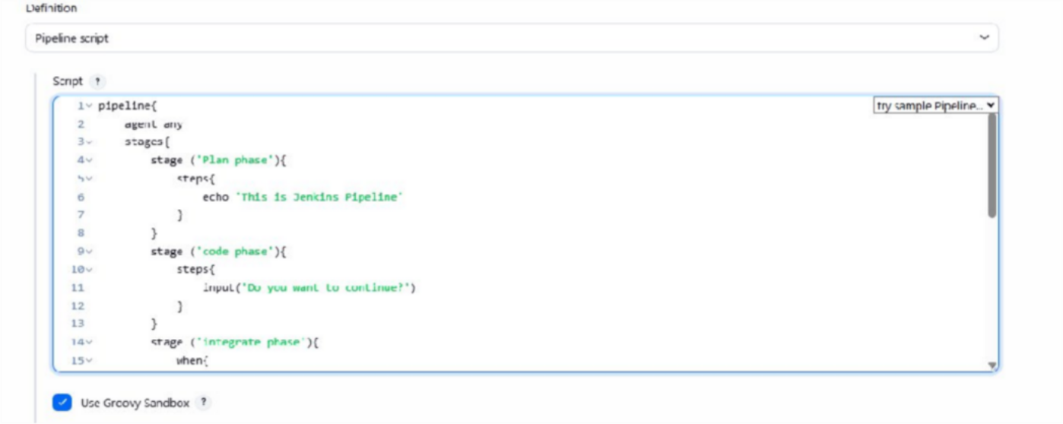
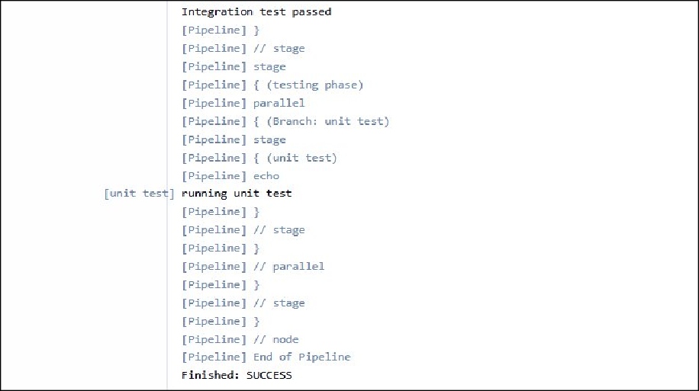
- Pipeline script Project with your own pipeline script

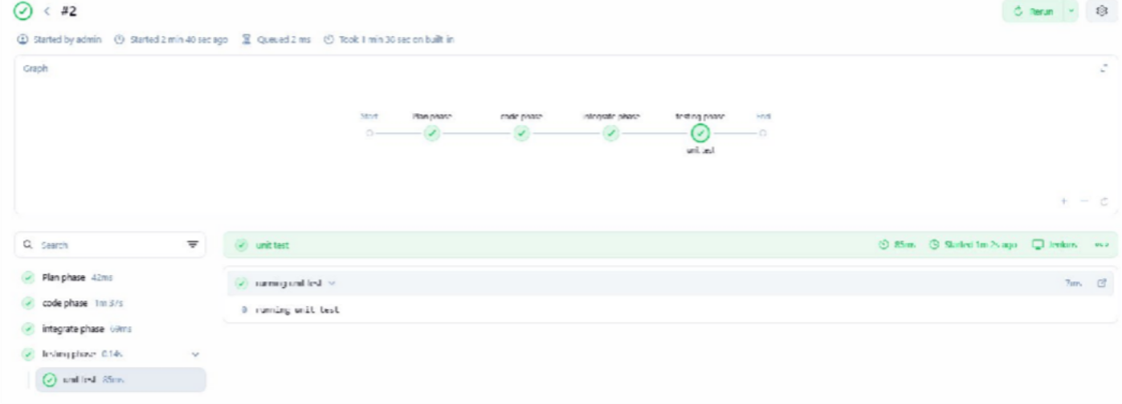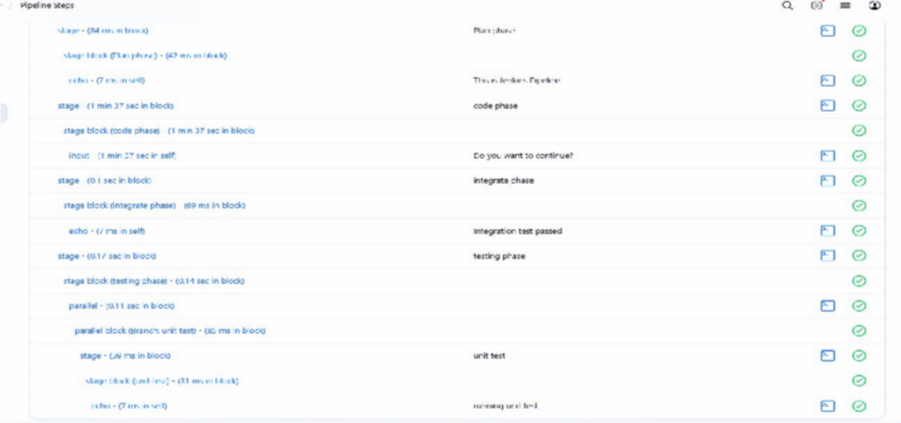

- Pipeline Project with GitHub.
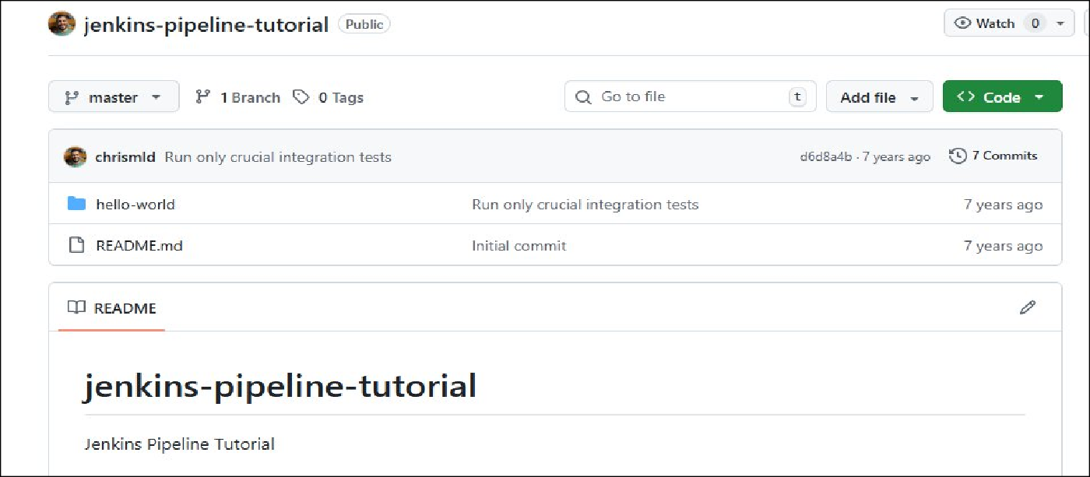

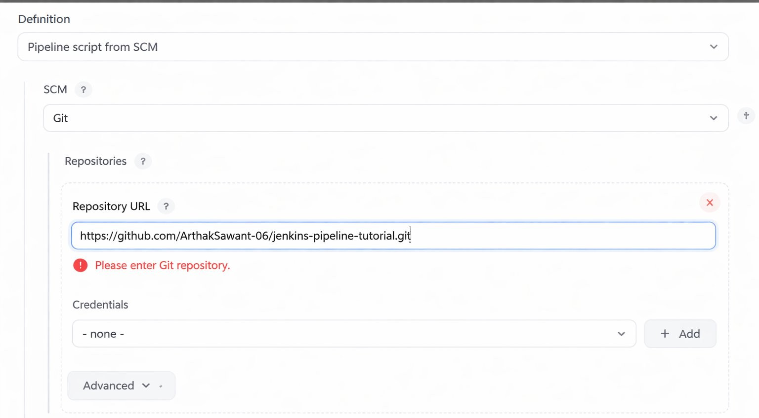
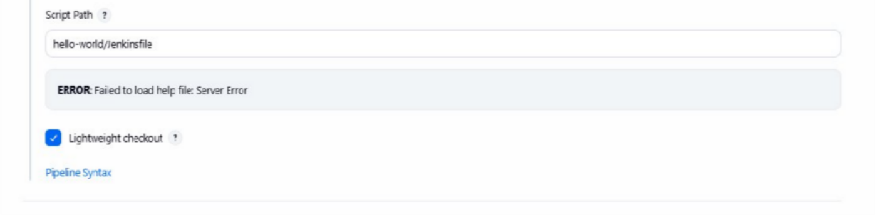
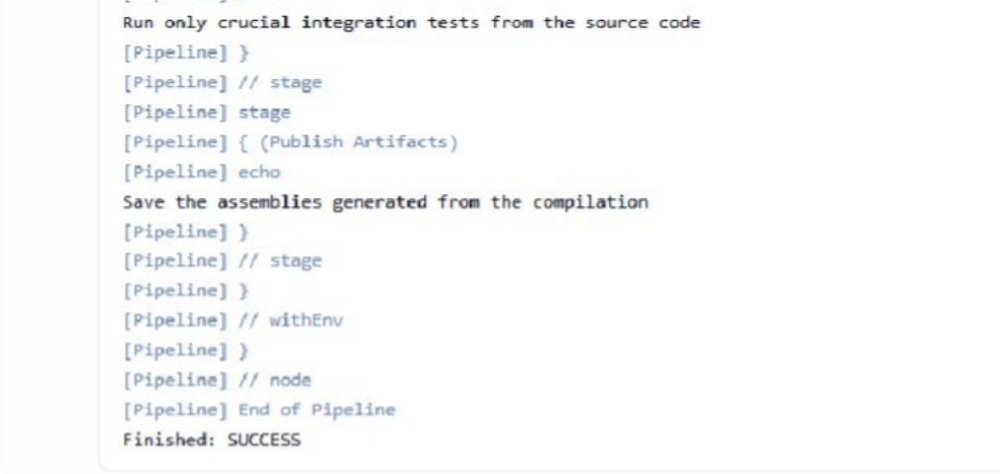
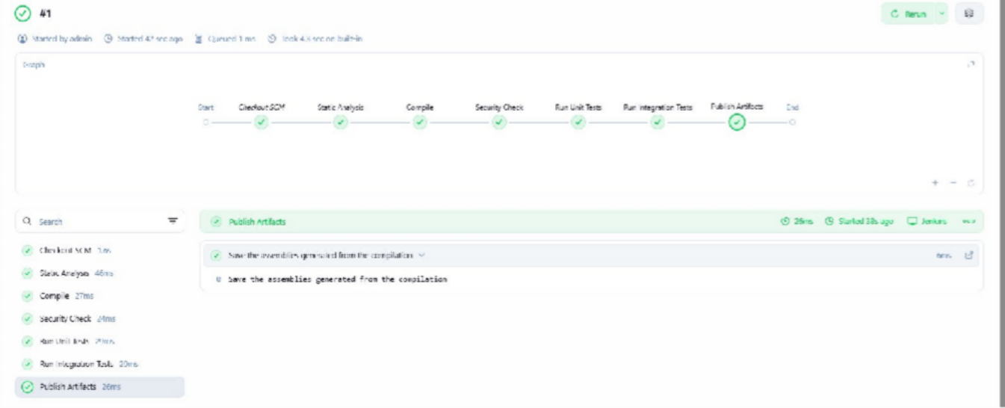

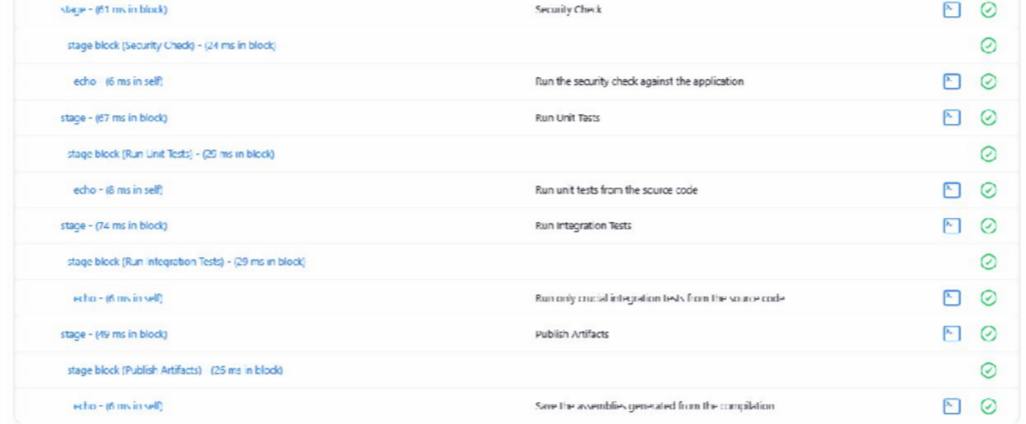

- Create pipeline project with pipeline script from SCM

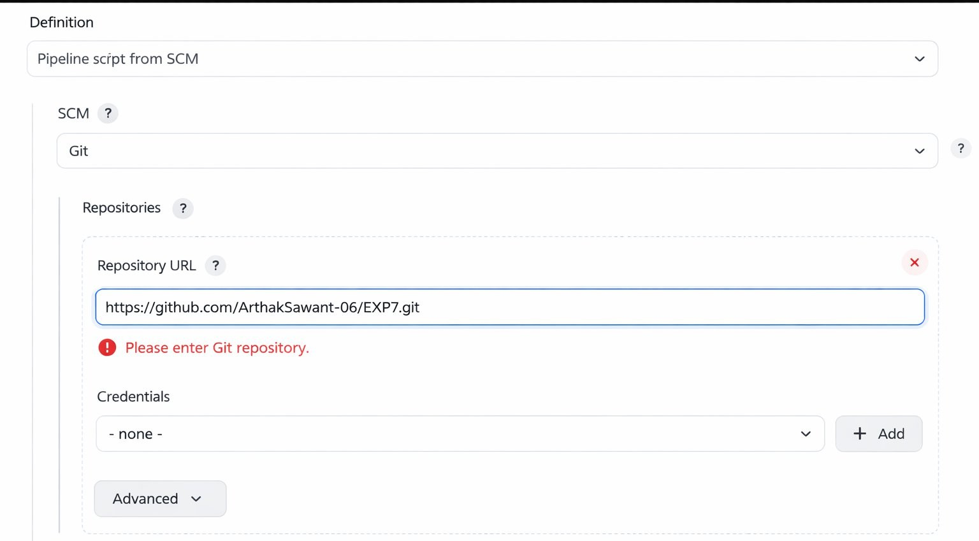

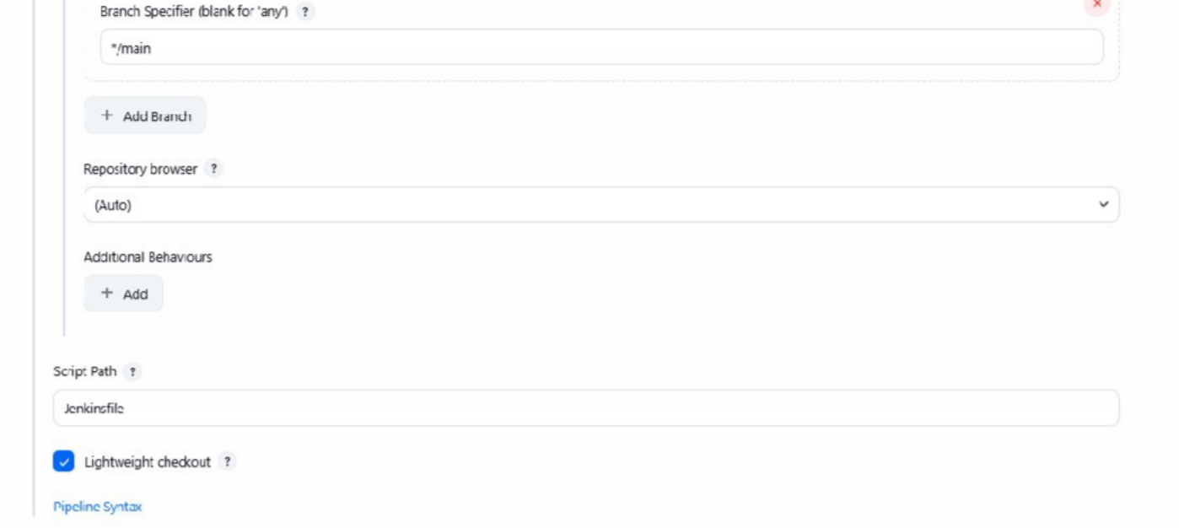
*/main is imp here

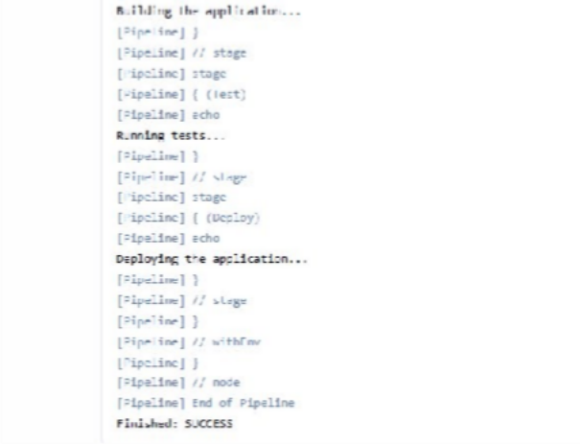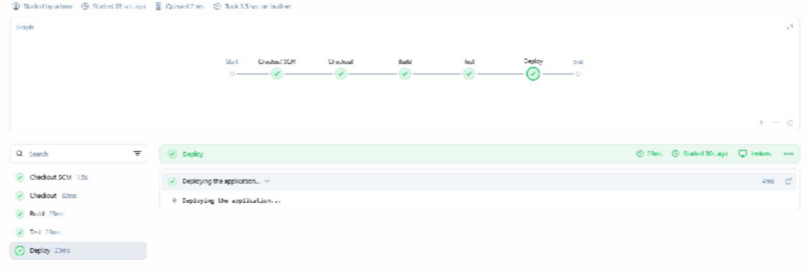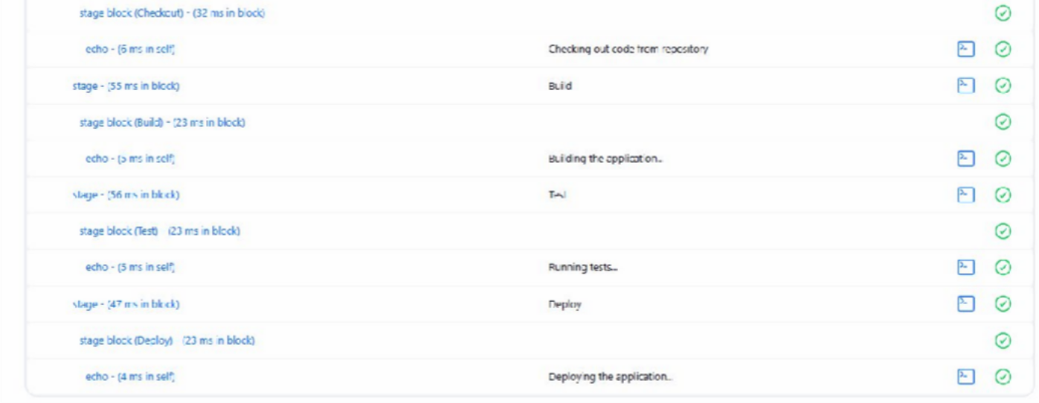
Pipeline Script
stage('Test') { steps {
echo 'Running tests...'
}
}

stage('Deploy') { steps {
echo 'Deploying application...'
}}}
pipeline { agent any

stages {
stage('Build') { steps {
echo 'Building application...'
}
}

